TOPIC
3 & 4

CONSUMER BUYER
BEHAVIOUR

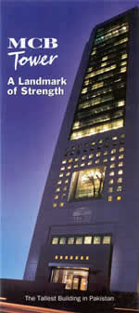
A Vision of the Future

PRESTENED TO:
PROFESSOR HASHIM SULTAN

PRESENT BY:

KHURRAM RAFIQ
NOREEN AKTHAR
aYESHA IMTIAZ
WASEEM ELAHI
SHERAZ GULL

TABLE OF CONTENTS

CONSUMER BUYER BEHAVIOUR ………………… 1

CHARATERISTICS AFFECTING CONSUMER BEHAVIOUR ………….................................. 2

TYPES OF BUYING DECISION BEHAVIOUR …..….. 3

CONSUMER BUYER BEHAVIOUR

“The buying behavior of final consumer---individuals and households who buy goods and services for personal consumption”

Consumer is buying our Smartcard to fulfill his or her various needs like.

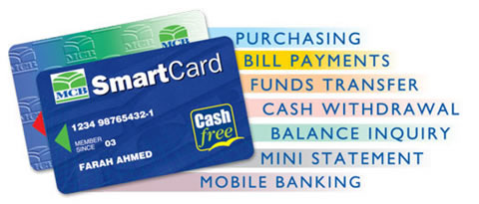

CONSUMER MARKET

“All the individuals and households who buy or acquire goods and services for personal consumption.”

All the professional and technical, manager, officials and proprietors, clerical, sales, craftspeople, supervisor, operatives, farmers, retired, student, homemaker, unemployed etc make our consumer market.

1

CHARATERISTICS AFFECTING CONSUMER BEHAVIOUR

Following are the characteristics which are affecting our consumer behavior.

CULTURAL FACTOR

Cultural factor also count in buying behavior of Smartcard as the time is pasting the people is moving these kinds of product, bank and financial institution are also investing and motivating consumer for the sale of these product.

SOCIAL FACTOR

Our product (Smartcard) is used

1. Upper Class
Upper upper
Lower upper

2. Middle Class
Upper middle
Lower middle

- Working Class

The people of these classes are our best customer.

2

PERSONAL FACTOR

Our product is used by people above 18 and MCB is mostly capturing the customers of between 26-45 and at this age mostly people are stable in their social and professional life.

PSYCHLOGICAL FACTOR

Psychological factor are also affecting the consumer behavior through advertisement.

TYPES OF BUYING DECISION BEHAVIOUR

These are two kind of behaviour in buying decision

- Involvement is high
- Involvement is low

In high involvement, there are Complex buying behavior and Dissonance-Reducing buying behaviour and low involvement there is Habitual buying behaviour and Varieting-seeking buying behaviour and consumer those who are using a product (Smartcard) is having Habitual buying behaviour.

3

